Name : Khushi Panwar

Roll No : 2021334

SEC (Python) PRACTICAL ASSIGNEMENT : 30.08.2022

Computer Science (3rd Sem)

**Question 1 : WAP to find if the input number is odd or even**

**Solution 🡪**

#program 1 : odd even number test

print("\n\t\t *** PRGRAM TO CHECK IF NUMBER IS EVEN OR ODD ***\n")

num=int(input("Enter a number : "))

if (num%2==0):

print(num, " is an even number!")

else:

print(num, " is an odd number!")

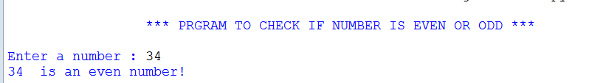

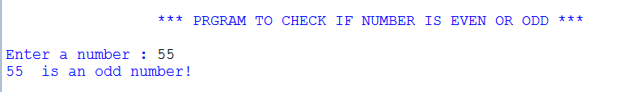

**Question 2 : WAP to find the greatest of three numbers**

**Solution 🡪**

#program 2 : WAP to find greatest of three numbers

print("\n\t\t *** PRGRAM TO FIND GREATEST OF THREE NUMBERS ***\n")

a=float(input("Enter the 1st number : "))

b=float(input("Enter the 2nd number : "))

c=float(input("Enter the 3rd number : "))

max=a

if (b>max):

max=b

elif (c>max):

max=c

else:

max=a

print(max, " is the greatest number out of three numbers")

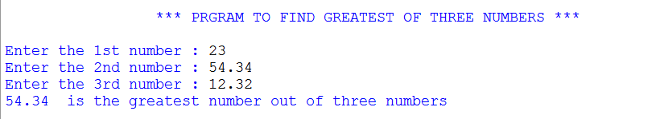

**Question 3: WAP to implement all types of operators**

**Solution 🡪**

#WAP to implement all types of operators

print("\n\t\t *** PRGRAM TO IMPLEMENT ALL TYPES OF OPERATORS ***\n")

print(" ---> Available operators : + , -, /, *, % ,//, ==, !=,>,<, >=, <= , and , or , not")

while (True):

print()

a=float(input("Enter operand 'a' : "))

b=float(input("Enter operand 'b' : "))

opr=input("Enter the operator : ")

#arithmetic operators

if (opr=='+'):

print("-> Operation = a+b (Addition) \n-> Output = ",a+b)

elif (opr=='-'):

print("-> Operation = a-b (Subtraction) \n-> Output = ",a-b)

elif (opr=='*'):

print("-> Operation = a*b (Multiplication) \n-> Output = ",a*b)

elif (opr=='/'):

print("-> Operation = a/b (Division) \n-> Output = ",a/b)

elif (opr=='%'):

print("-> Operation = a%b (Modulus/Remainder) \n-> Output = ",a%b)

elif (opr=='//'):

print("-> Operation = a//b (Floor Division) \n-> Output = ",a//b)

#comparision operators

elif (opr=='=='):

print("-> Operation = a==b (Equality Comparision) \n-> Output = ",a==b)

elif (opr=='!='):

print("-> Operation = a!=b (Inequality Comparision) \n-> Output = ",a!=b)

elif (opr=='>'):

print("-> Operation = a>b (Greater than) \n-> Output = ",a>b)

elif (opr=='<'):

print("-> Operation = a<b (Smaller than) \n-> Output = ",a<b)

elif (opr=='>='):

print("-> Operation = a>=b (Greater than or equal to) \n-> Output = ",a>=b)

elif (opr=='<='):

print("-> Operation = a<=b (Smaller than or equal to) \n-> Output = ",a<=b)

#logical operators : and , or ,not

elif (opr=='and'):

print("-> Operation = a and b (Logical AND) \n-> Output = ",a and b)

elif (opr=='or'):

print("-> Operation = a or b (Logical OR) \n-> Output = ",a or b)

elif (opr=='not'):

print("-> Operation = not a (Logical NOT) \n-> Output = ", not a )

else:

print("ERROR : INVALID OPERATION ")

